Quinte Field Naturalists
General Meeting of the Membership
February 16, 2026 @ 7:00pm
Maranatha Church
1. Welcome: Lori Borthwick
2. Land Acknowledgement
3. Housekeeping items:
Directions to washrooms.
Next meeting: March 16, 2026: Andrea Kingsley presents ‘Arctic Bird Banding and Running from Polar Bears’.
Treats: Thanks to Bernadette Hymus and Barry Lieff. Sign up sheet available on snack table.
A reminder that it is time to renew your membership. $25 single, $40 family, $10 youth. Please take your name tags home and remember to bring them back with you at each meeting.
4. Annual Celebration Dinner: Brett Nielsen spoke about the upcoming fundraising dinner, May 20th, 2026 at a new venue this year: St. Matthew’s United Church, 25 Holloway St., Belleville. The guest speaker will be Mark Raycroft, Wildlife Photographer and Author. A buffet style dinner menu will offer chicken and vegan dishes. The cost this year is $40. There will also be a silent auction.
5. Tree Planting Subcommitte Report: Lori Borthwick
Led by Greg Parsons, 2025 was a very successful year.
Date | Where | Planted | Supported by
Sept 19th | Cascade Park | 220 trees, 15 large trees, 98 shrubs, 40 wildflowers | LCBO, Sprout’s Earth Products, Quinte Conservation, City of Belleville
Oct 3rd | Clifford ‘Sonny’ Belch Park | 925 wildflowers | Our plant sale proceeds,  Home Hardware, Tree Canada, Bird Friendly City who procured a Nature Canada Grant, City of Belleville
Oct 4th | “ | 928 more wildflowers, 422 shrubs, 20 large trees
Of course, this was only possible with the help of school children from Harmony Public School and St. Teresa’s Secondary School, Brownie groups and many club members and Belleville citizens who answered the call to help plant and to weed, water and keep alive what had been planted.
Over the last 3 years, we have planted over $66,000 worth of trees, shrubs and wildflowers, translating into more than 500 trees, 750 shrubs and 3,000 wildflowers from Tweed to Belleville.
6. Plant Sale: Last years plant sale raised over $10,000.
This year, our sale is set for May 16th, 2026 at St. Joseph’s Catholic Church parking lot, 399 Victoria Ave., Belleville. Please think about what you can donate to the sale and if you can volunteer to help out.

7. Seedy Saturday: QFN will have a table at Seedy Saturday on February 28th, at Centennial High School, Belleville, running from 10:00am to 3:00pm. If you can volunteer to assist, please contact Lori. The event is free, so hopefully we will see you there.
8. Alcohol Containers Collection: John informed us that the 2025 effort raised $3,530 ($500 of this was contributed by the club itself) which was matched on Giving Tuesday and donated of the Nature Conservancy of Canada. Since 2022, QFN has raised $12,660, translating into over $25,320 for NCC. We will run this program again in 2026. If it is easier for contributors to cash in the cans and just give the funds to John, please feel free to do so.
9. Outings: On February 12th, several members went to Algonquin Park for the day and went to Opeongo Road, the Visitors Centre, Mew Lake Campground and the Spruce Bog Boardwalk Trail. They stopped for dinner in Bancroft at the Brew Pub on the way home. John is working on a lineup of hikes for the upcoming “warmer” seasons and is open to ideas and suggestions.
There will be a Wildflower Walk as part of the SSJI on May 9th at Point Petre, PEC for those interested.
10. Nature Minute: Steven Poole presented a photographic look at Algonquin Provincial Park. The park is open all year round and along the Highway 60 corridor, provides opportunities to hike, snowshoe and ski on its many trails and observe an abundance of wildflowers, animals, birds and amphibians.
11. Guest speaker: Lori introduced Greg Dickson, Loyalist Professor in environmental science and Karrin Broadhurst, retired Environmental Consultant. They spoke about climate change, increased storm intensity, rising temperatures (higher in urban areas with less greenery), and its effect on animal migration, the soil’s ability to absorb water, algae bloom increases as lakes heat up, insect infestations…and ultimately on changing plant/tree species and migratory bird diversity.
Animal agriculture was discussed, 60% of all biomass is animals raised for slaughter. These animals are also high greenhouse gas emitters and require more water than crops do to raise. Protein can come from other sources.
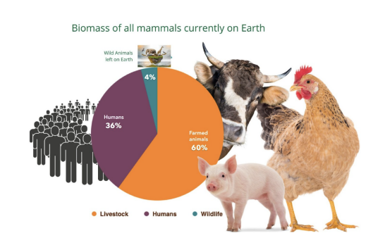
Belleville observations noted by participants commented on its focus on expansion, the loss of urban canopy, tree trimming focused on protecting infrastructure with little regard for the tree’s survival. Though the outlook was commented on as being gloomy, several suggestions were made to help mitigate the effect such as solar panels, rooftop gardens, plant walls, Pocket Forests, planting MORE native trees and increasing awareness.
John Lawry thanked Greg and Karrin for their presentation.
Closure: Lori Borthwick
Minutes prepared by Debi Butler

